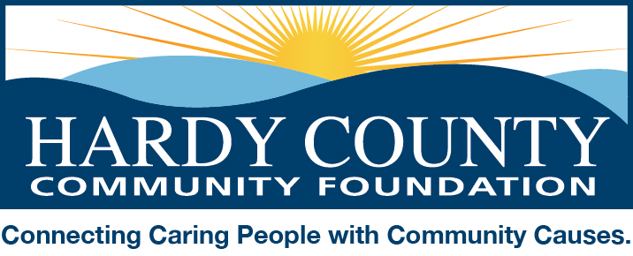

May 15, 2019

Dear Friends:

The Hardy County Community Foundation is gearing up for its sixth annual Volunteer Hardy event, an initiative designed to promote volunteerism and encourage support for our local community service sector. This year’s initiative will take place during the months of August and September, specifically, August 17th through September 22nd.

Here’s how it works:

Nonprofit organizations, school and community groups, businesses, and families are invited to coordinate fundraising activities during the five-week period of August 17th through September 22nd. The Community Foundation will help promote these events and issue periodic calls-to-action encouraging people to learn more about and get involved with the events, the sponsoring organizations, and/or the causes the fundraising events will support. Participants keep most of the money raised from their activity but are asked to contribute 20% to the Community Foundation’s Community Impact Fund (our unrestricted endowment which is used to support a variety of local nonprofits and charitable programs).

In November we will highlight the efforts of all participants at our Spirit of Hardy County celebration. The Community Foundation will randomly select three participants to identify one of their members who exemplifies the volunteer spirit for their organization/event to be recognized at the dinner.

For those organizations focused primarily on volunteer activities without a fundraising component, we want to recognize you too! Submit a summary of your organization’s volunteer activities for a 12-month period beginning July 1, 2018 and ending June 30, 2019. We will select an organization to recognize as our 4th Spirit of Hardy honoree.

Attached is a summary of what we need from participants, including deadlines for responding. We hope you will consider joining us in this annual celebration of volunteerism in Hardy County.

Please contact me by email (apancake@ewvcf.org) or phone (304-538-3431) for more information or to notify us of your intent to participate. And please feel free to pass this information along to others.

I look forward to hearing from you soon!

Sincerely,

Amy Pancake

Hardy County Community Foundation - 2019 Volunteer Hardy Details

To participate in Volunteer Hardy, please email the following to apancake@ewvcf.org:
- Notify the HCCF of intent to participate in the Volunteer Hardy event by July 15 (to be included in paid advertising). Please included the following information:
- Name of organization/group/business/family
- Name/phone/email of contact person (for correspondence with HCCF)
- Website or where to find more information (to include in promotional material), if applicable
- Provide details about your event that will take place between August and September, including:
  - Brief description of activity
  - Project or cause proceeds from the activity will benefit
  - Date, time, and location
  - Pictures of past volunteer activities for Facebook promotions
  - Optional, as applicable – Details about your organization (meetings days/times; types of activities; how to become a member) for us to post on Facebook periodically

- LIKE our Facebook page (https://www.facebook.com/HardyCountyCommunityFoundation) and visit it frequently to help share information about the event.
- Plan to attend our Spirit of Hardy County celebration dinner on November 7th. (Three participating organizations/groups/families will be invited to select a volunteer to be honored at the Spirit of Hardy celebration, and will be asked to introduce him/her or to provide comments about the individual to be read by a HCCF board member).

To nominate your organization for Spirit of Hardy based on volunteer activities
- Please submit a detailed description of the organization’s activities between July 1, 2018 through June 30, 2019. Feel free to include supporting documentation (flyers, pictures, news articles, etc.).
We will promote all organizations that submit a nomination through social media and at our Spirit of Hardy Celebration. If you’re interested in growing your membership, please be sure to include information about how people can get involved. We will select one organization to honor at the Spirit of Hardy celebration. Please submit your nominations by July 15th.

Please email Volunteer Hardy and Spirit of Hardy information by July 15th, 2019 to apancake@ewvcf.org. For more information, call 304-538-3431.

