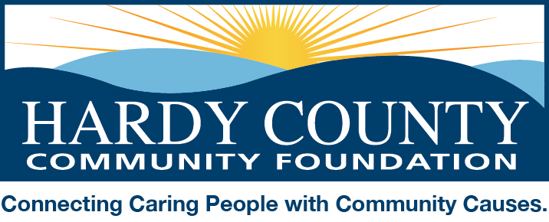

August 12, 2019

Dear Friends:

Each year in November, the Hardy County Community Foundation celebrates volunteerism at its Spirit of Hardy County event in November. In past years we’ve invited our Volunteer Hardy participants to identify one of their members who exemplifies the volunteer spirit for their organization to be recognized at the dinner.

Because our Volunteer Hardy initiative includes a fundraising component we know that we are excluding many volunteer-based organizations from the opportunity for recognition.

This year we’re changing that and would like to invite you to nominate your organization or a special volunteer within your organization for recognition by submitting a description of the organization’s (or individual’s) volunteer activities over the past twelve months (or a timeframe relevant to the work of your organization/group). Feel free to include supporting documentation (flyers, pictures, news articles, etc.).

Please submit your nomination by email, fax, or mail (see below) by September 23rd.

We will select one organization (individual) to honor at the Spirit of Hardy celebration, in addition to the individuals selected by our Volunteer Hardy participants. But we will acknowledge and promote all organizations that submit a nomination. If you’re interested in growing your membership, please be sure to include information about how people can get involved.

Please contact me by email (apancake@ewvcf.org) or phone (304-538-3431) for more information or to notify us of your intent to participate. And please feel free to pass this information along to others.

I look forward to hearing from you soon!

Sincerely,
Amy Pancake

